**Week 3 – Iterated Designs and prototypes**

Published by Guimin on February 19, 2021

We have a very productive week! Last week, we had an Initial design for our game. We chose to combine the Bodega Tycoon idea with some storytelling elements. We also came up with three key financial interactions in the game: Budgeting, Banking and Investment. Based on the achievements of the last, we have an improved gameplay flow!

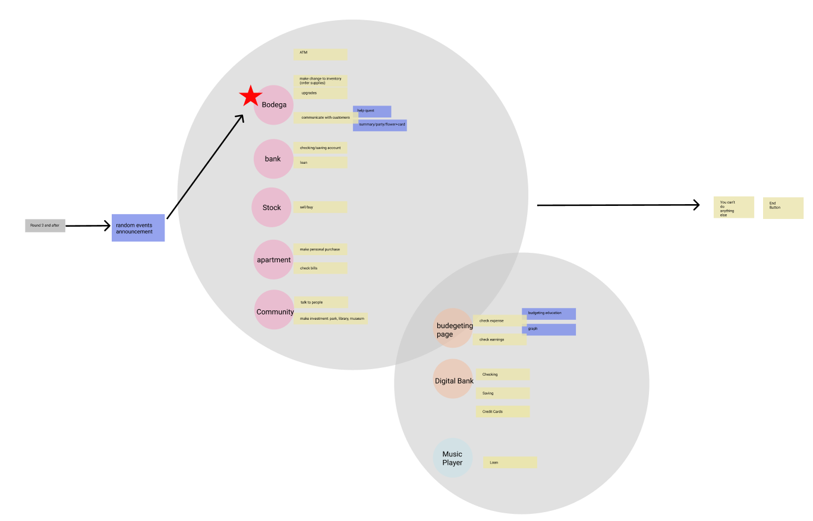

There will be more game components after the tutorial part. Players can go to their Bodega to manage their inventory and communicate with other characters. They can go to the stock market to invest. They also go to the bank to manage their assets.

We also have an initial UI design this week. Based on the game flow, The game setting UI, Tutorial UI, Inventory UI, customer UI and banking UI have been designed. We refer to some popular games like Animal Crossing to come up with a simple but readable design. Also, we integrate some functions like budgeting and banking into a mobile Phone UI. Players can refer to information conveniently through this.

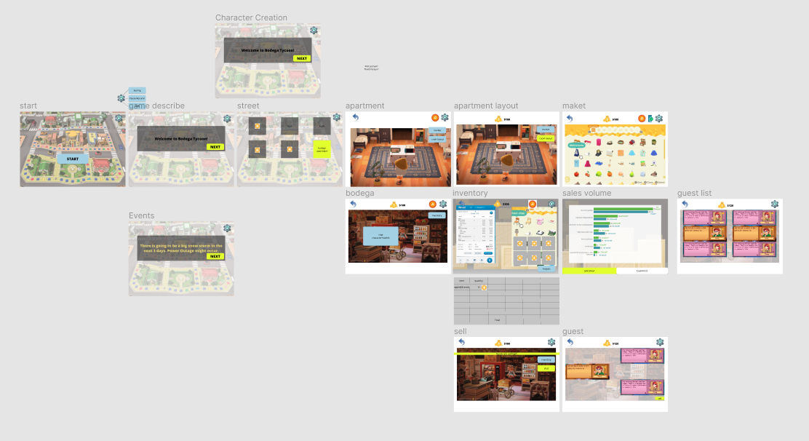

We also built our first prototype this week. A top down world scene with a UI template was built. This demo was used to show the player’s view. Basic UI elements were integrated in this demo.

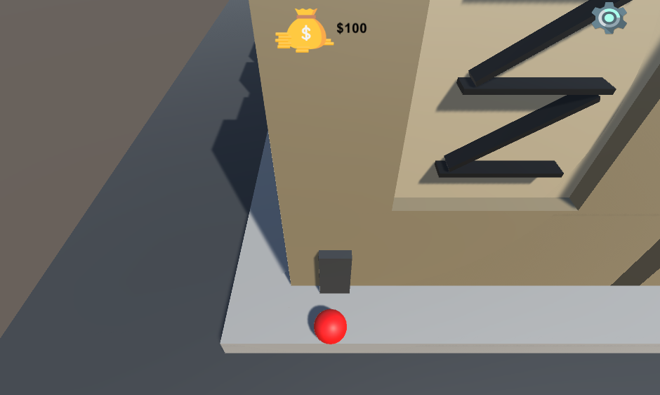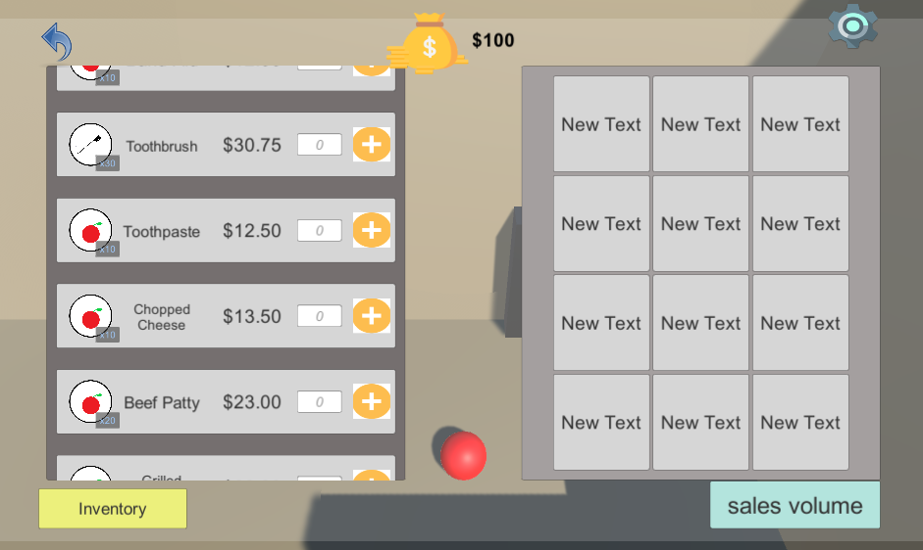

Another example is to simulate the stock market. The prize of stock floats based on random parameters. We will integrate this feature with our game in the future.

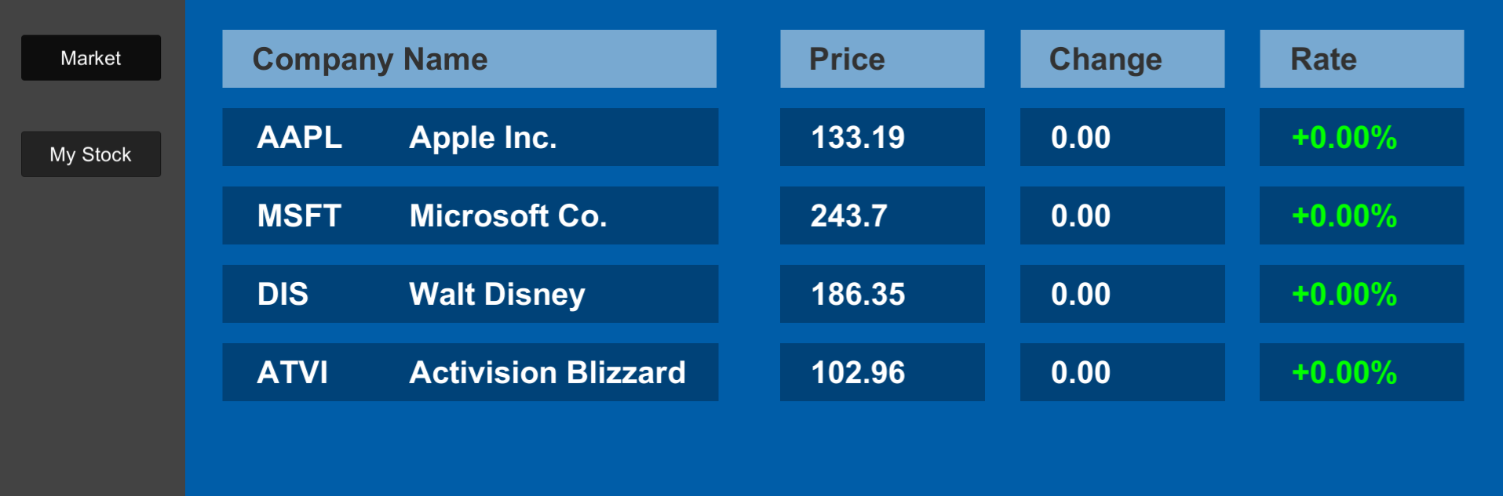

Week 3 is a very productive week for us! We have iterated game ideas and UI designs. We also built our first game prototype! Next week, we will have our quarter presentation.